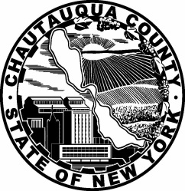
CHAUTAUQUA COUNTY DEPARTMENT OF HUMAN RESOURCES

3 N. Erie Street • Room 144 • Gerace Office Building, Mayville, NY 14757-1007 • Email cchrs@chqgov.com
Phone (716) 753-4237 • Fax (716) 753-4686 • Website chqgov.com

CORONER (PART-TIME)
(No Benefits)

Chautauqua County Department of Health and Human Services is seeking applications for a Part-Time Coroner. A Coroner, in conjunction with a Coroner’s Physician and according to all applicable State and Local statutes, is responsible for investigating deaths within Chautauqua County which occur without medical attendance or which result from accidental, suicidal, criminal, suspicious, or undetermined causes. On call and off hour availability is required. Formal education in police forensics, mortuary science, criminal justice or health related field with associated experience in investigative work is preferred.

Candidate will be chosen from submitted applications. Applications can be found on the Chautauqua County website: chqgov.com, click on “Employment.”

Please send completed application along with a resume and cover letter to:

Chautauqua County Department of Human Resources
Gerace Office Building
3 North Erie Street, RM 144
Mayville, NY 14757

Equal Opportunity Employer

