Red sections to be completed by Agency Staff
Agency:
Program Title:
Date(s) Submitted:

First Name:
Age:
Female Male

Program Performance Measure Pre-Post Survey

Pre- Survey Answer |  | Post -Survey Answer
Circle the one that is better for your heart  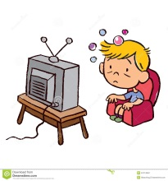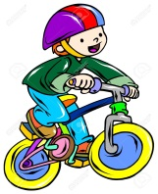 |  | Circle the one that is better for your heart
Circle the one that will make your bones stronger |  | Circle the one that will make your bones stronger
Circle the one you call for an emergency  923 911 |  | Circle the one you call for an emergency  923 911
Circle what happens when you don’t litter  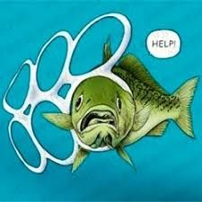 |  | Circle what happens when you don’t litter

Satisfaction Survey

QUESTION | YES | NO | SOMETIMES
I enjoy coming to summer program
Staff gave me choices of activities
I feel safe at program
Do you want to come back next year

Write or draw

My favorite thing at summer program was

My least favorite was

